Nishay Madhani (00212195)

**Program Structures & Algorithms**

**Fall 2021**

**Assignment No. 1**

## 1. **Tasks Performed**

1. Complete the implementations for the methods found in RandomWalk.java.
2. Run it against all unit tests.
3. Extend the java code with Jchart to be able to log the data and plot the graph.
4. Compare the function received from the graph with other single-variable functions such a N^2, lg N, ln N.

## 2. **Conclusion**:

**d = √N,** d = average distance after N steps

## **3. Evidence**

| **N** | **D** |
| --- | --- |
| 913 | 26.811754890869153 |
| 1904 | 38.73372357457608 |
| 707 | 23.574405085330024 |
| 2465 | 43.99567517612149 |
| 1314 | 32.10189765924931 |
| 1060 | 28.89543616125455 |

To find the relationship between the number of steps and the average distance traveled by the random walk, we can plot the data with N on the x-axis and d on Y-axis.

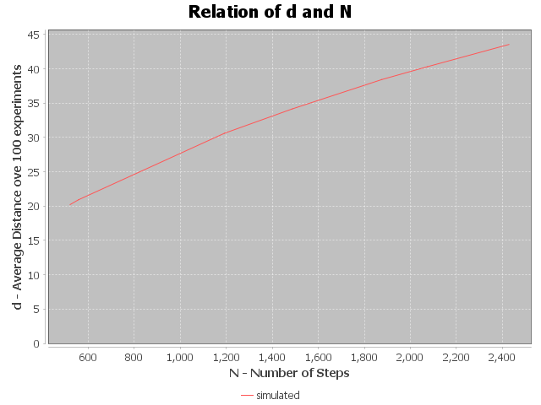

Now, the plot and data we have generated from our simulations can be compared with other single variable functions such as N/2, N^2, ln N, , Functions such as N/2, can be eliminated as the values of d do not correlate with them.

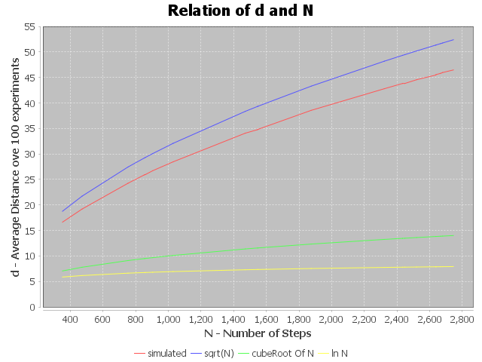

From the above plot we can infer that the closest approximation we have for d = f(N),is d = .

### 3.1 **Proof**

1. At each step we can move either towards the top,left,bottom or right in unit direction. This implies that x can be incremented by +1/-1 or y can be incremented by +1/-1.
2. Now since the probability of each direction is the same, for a large enough M we should be able to get the average distance to be equal to 0. Since that is not the case and the drunkard does move in a direction, we can take the distance to be a euclidean distance between the origin and the current location.
3. Therefore for N, where *N* is the number of steps, the average distance over *m* simulations is denoted by *d* is:

## 

* 1. On expanding this equation we can remove the pairs of (xi * xj) since they would all sum upto 0.
  2. We would be left with = X1 +X2….+.Xn +Y1 + Y2 + .….+ Yn;

1. Since they all are in the unit direction of +1/-1, and have equal probability.

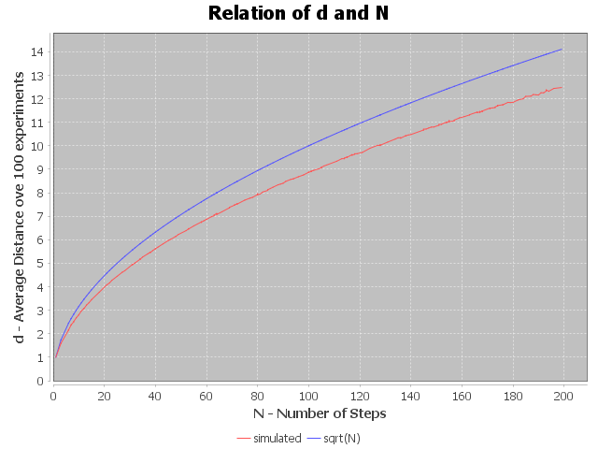

*Conducted for N=200, M = 100,000.*

## 4. **Output**

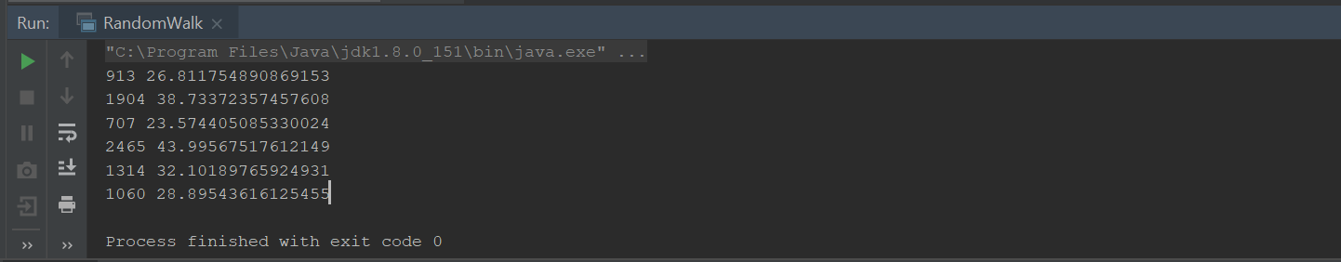

## 5. **Unit Tests**

